УДК 37.03

Solntseva E.S.

HOW DO PRIORITIES IN MEDIA LITERACY SKILLS DIFFER AMONG RUSSIAN SCHOOLERS AND STUDENTS?

Abstract: The article is devoted to the study of media literacy skills in young people. Based on understanding of media literacy that has been developed among researchers of the latest years, we provide research into the priority of media literacy skills in young people as a result of a sociological survey of Russian schoolers aged 10-15 and students aged 18-29. Generally, media literacy skills include abilities to read and write in mass media environment; to distinguish fake from truth and check facts; to distinguish opinions from facts; to recognize the emotional background of the message; to think critically; to evaluate the message in terms of the opposition “good – bad”. This work results in establishing the following priority: for schoolers the ability to evaluate mass media content in terms of the opposition “good – bad” and for students the ability to think critically.

Key words: media literacy, priority, schoolers, students, skills, survey

**1. Introduction**

Despite the fact that there is a large number of definitions of media literacy and a general definition of the subject of media literacy, the priority of skills included in it has not yet been described. Research into the phenomenon of media literacy has been carried out in Russia since the 2000s, with the main emphasis of these studies being on the definition of this concept and methods of developing media literacy [12], as well as the comparison of media, information and computer literacy [4]. Sociological surveys regularly conducted in Russia are devoted, first of all, to assessing the level of media literacy of the population (see, in particular, the comparative analysis of the ZIRCON research group by I.V. Zadorin and co-authors).

The most recent study (over the last 3 years) on media literacy regards this phenomenon as part of the inclusive education of students with disabilities [25]. Thus, media literacy today becomes associated with human rights and freedoms, for example, with the right to education or freedom of expression, in other words, there is a shift in media literacy into the legal field [24]. Competent consumption and creation of media content implies following certain rules aimed at not violating the rights and freedoms of other participants in media communication. In the Russian professional community, the main document is the Moscow Declaration on Media and Information Literacy, approved as a result of the international conference “Media and Information Literacy in Knowledge Societies”, held in Moscow in 2012. According to the document, media and information literacy is understood as a set of attitudes, abilities and skills that allow one to access information and knowledge, analyse, evaluate, use, create and disseminate them with maximum productivity in accordance with legal and ethical standards and respect for human rights [23]. Media literacy is associated with information or digital literacy. Then media literacy also includes “netiquette” (virtual etiquette).

Regarding the phenomenon of media literacy, it is at its core a fundamental skill of literacy, that is, mastery of oral and written language [2], the ability to read and write, to understand the meaning of what is written and heard, and to express your thoughts. This is recognized as one of the most important indicators of the cultural level of a population and is directly determined by the level of economic and political development of society. On the other hand, media literacy stems from the notion of “media” ‑ “a set of various types of data (in addition to text messages) containing additional audio and visual information, as well as means for conveying this data to the recipient (media)” [5]. Thus, in general, media literacy refers to the skills of reading and reproducing media data.

In modern scientific literature, the term further acquires a whole range of meanings, including, in particular, the ability to analyse messages in different types of media. The purpose of such an analysis is to detect various types of influences, eg. manipulation in the form of propaganda or censorship, fake messages, subjective presentation of facts and presentation of information through the prism of the interests of a certain group of population, for instance, owners or sponsors of the publication [8].

From this point of view, media literacy comes closer to the concept of critical thinking. Critical thinking is a system of judgments that is used to understand things and events, to draw rational conclusions and allows one to make informed assessments, interpretations, and correctly apply the obtained results to different situations and problems [7]. It aims at autonomous and critical interpretation of the flow of information, its content, value and consequences. In relation to the field of media, to think critically when familiarising with media content means to make one’s own conclusions about current events based on the information received. In addition, analysis of the flow of information in modern media also includes the capability to assess the emotional background of a message and its position in the “bad ‑ good” opposition, as well as the capability to distinguish opinion from fact, and fake from truth. It is of a greater importance as opinion, subjective interpretation of facts, the emphasis that authors of a media message put when creating their content can negatively influence the audience and give rise to an unreasonable emotional reaction, and moreover, fakes being one of the means of deliberate misleading and manipulation are intended to scare, misinform or deceive the addressee [10]. In this regard, the skill to recognize a subjective author’s assessment or false information should also be included in media literacy.

Critical thinking and analysis of media information is further transformed into critical understanding, that is, the development of one’s position and views based on the critical perception of information. Critical understanding of media content contributes to the creation and strengthening of an individual perspective on issues within mass media. Critical understanding is described as a tool of democratic processes, as a key factor in the formation of policies to promote media literacy [8]. Ultimately, critical thinking and critical understanding reflect a certain level of media literacy of people, which affects their behaviour in society, that is, leads to specific actions/reactions of people in society, therefore the significance and relevance of research in this area is beyond doubt.

Media literacy can also be understood as a movement to help people understand, create and appreciate the cultural significance of audiovisual and printed texts [1, p.1.; 6], that is, as the ability to analyse the cultural context of media content. The historical era and social conditions in which a media message develops will directly influence the nature of the perception of such a message. The context as a whole ‑ linguistic (specific lexical environment of a particular word) and extralinguistic (time, place, author) [6], ‑ becomes key factor in understanding modern media and brings the phenomenon of media literacy into the field of interdisciplinary cognitive-discursive research.

In addition, media literacy includes the capability to create media messages, which additionally implies recipients to become passive viewers and “prosumers”. A prosumer takes part in media production and is familiar, for example, with practices such as content uploading, sharing, networking, remixing, etc. [22]. This also includes the skill to recognise different genres and forms of media content and work with them.

Like any other skill, media literacy is developed under certain fundamental criteria that affect the learner’s ability to acquire certain skills. Among the factors that determine the criteria for media literacy are considered, for instance, the level of education and age [13], as well as the availability of media, the level of development of the media industry and civic education of society members [18, p. 157].

Media literacy needs to be taught, like reading or arithmetic. Considering media literacy as part of media education, we come to certain indicators that must be achieved in order for a person to be considered media literate [28]. These indicators include, for example, among personal skills, the degree of proficiency in technical means of creating media content (computer, programs, etc.) [26; 16; 14]; cognitive abilities of encoding/decoding messages, their analysis and interpretation [21], as well as among socially determined skills ‑ the degree of proficiency in communication skills (interaction with other participants in the media space) [19]. Research on the achievement of these indicators is published annually in reports on media literacy in different countries (see, in particular, the reports of P. Celot “Study on Assessment Criteria for Media Literacy Levels. Final Report. Brussels” (October 2009), “DSMS Online Media Literacy Strategy” (Crown copyright 2021), "U.S.Media Literacy Policy Report" (2020))

Therefore, media literacy is generally understood as the ability to analyse media content and the context of its existence and development, the ability to create media content, the ability to behave within the framework of legal norms and rules of etiquette, and on the other hand, the process of learning and acquiring relevant skills within the framework of media education. In turn, media education is becoming an integral part of modern lifelong education [15; 9]. However, the main emphasis is on acquiring media literacy skills among young people [27; 3; 17], that is, at earlier stages of personality formation, for instance among schoolchildren and students aged 10-29.

In this study, an attempt is made to establish the priority of the skills included in media literacy depending on the criterium of age. In this research we investigate the opinions of respondents among schoolers and students by conducting a survey of what they themselves consider to be the key skills of media literacy. The survey establishes the dependence of priority skills for developing media literacy on the age of the audience. The present study implies to fill up the current lack of fundamental studies in the field that would reflect the idea of priority areas in media literacy and corelation of media literacy skills with the age of audience.

**2. Results**

The aim of the study was to establish priority skills in the field of media literacy among Russian schoolers (33 respondents aged 10-15) and students (52 respondents aged 18-29). The survey was conducted in person, and responses were recorded in writing (for more details see Ref. [20]). The main purpose of the survey was to obtain information about respondents’ opinions regarding which of the proposed skills they consider a priority in learning media literacy. Respondents were asked to answer the question “What do you consider the most important in media literacy ‑ competent work with media content?” and further to prioritize the given skills of media literacy and to rate them from 1 to 3 (with 1 most important and 3 least important). The following hypothesis was in question: the skills prioritised depend on the age of a young person.

The options given included the most common skills identified in the field of media literacy as studied above:

• know the meaning of slang words

• recognize the emotional background of a message

• understand the implied sense

• be able to distinguish opinion from fact

• be able to create attractive content

• fact-checking (checking the reliability of a fact)

• be able to read

• be able to distinguish fake from truth

• think critically

• evaluate the media message in terms of good/bad

The data were obtained anonymously and used in general to statistically evaluate priorities in media literacy as identified by the respondents. Depending on the age of the audience, the needs of its media literacy differ significantly. The percentage of priority skills marked by Russian schoolers and students from the focus group is shown in the following chart (Fig. 1):

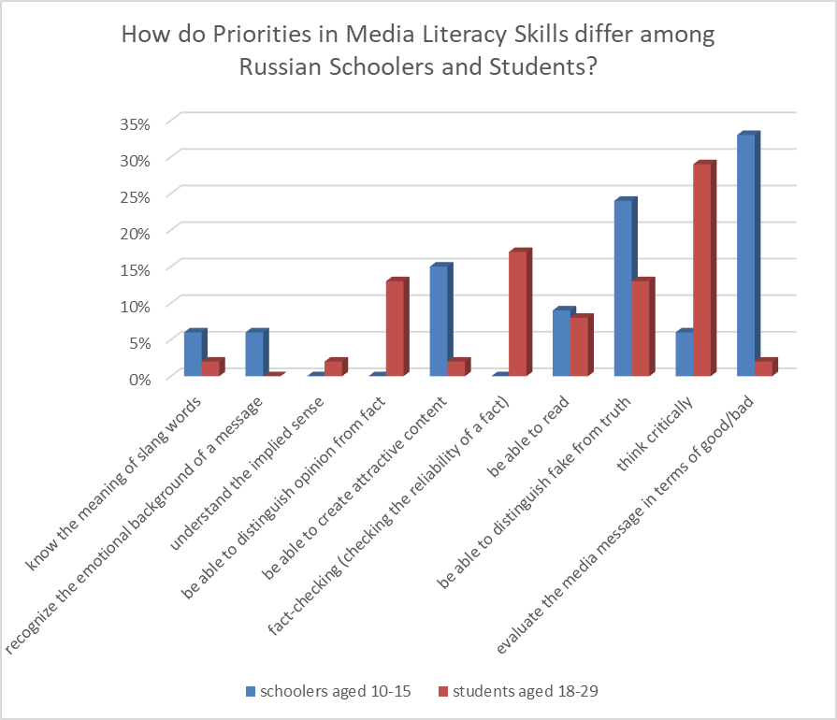

Fig. 1. How do Priorities in Media Literacy Skills differ among Russian Schoolers and Students?

As it is evident from the chart, the majority of schoolers see the skill of evaluating the media message in terms of good/bad as their priority (33%), unlike students with only 2%. Students, on the contrary, see critical thinking as their priority in media literacy skills (29%). The second popular skill is among schoolers to “be able to distinguish fake from truth” (24%) and among students “fact-checking” (17%). The third place is taken by the skill of creating an attractive media content (15%) among schoolers and both distinguishing opinion from fact and fake from truth (13% each) among students.

The lowest priority was given among schoolers to the ability to read (6%), to recognize the emotional background of a message (6%), to know the meaning of slang words (6%) and think critically (6%). The options to “understand the implied sense” and “fact-checking” were not chosen at all. Among students the lowest priorities were understanding the meaning of slang words (2%), the ability to create attractive content (2%) and to evaluate messages in terms of good/bad (2%), as well as to understand the implied sense (2%). At the same time, the ability to recognize the emotional background of a message was not chosen.

In general, when comparing the results of surveys of Russian schoolers and students, a difference in priorities becomes clear: for schoolchildren the main skills in the field of media literacy are based on recognizing positive and negative in media content, and for students the main skills are related to critical thinking. At a more mature age, a more complex skill of critical perception of media content appears, in which, in addition to the actual ability to intuitively distinguish fake from the truth, there arises the need for reasonable confirmation / refutation of the information received, i.e. critical thinking and fact-checking. Thus, the assumption of the original hypothesis about the dependence of the priority skills in media literacy among young people on their age was confirmed.

**3. Conclusion**

Media literacy includes basic skills in reading and writing, technical skills and digital data processing skills, and further more complex skills of critical perception of media content, analysis of its context, recognition of various manipulation techniques, assessment of the emotional component of the message. As a result of the survey described above, a certain priority was established for the skills included in media literacy among Russian schoolers and students and the dependence of these skills on the age of the audience.

The skills that form media literacy can be called age-oriented since the need for them and the degree of their development are directly related to the age of the audience. Schoolers need, first of all, to evaluate the message in terms of good/bad to make it clear if they will read further or not, and also not to be influenced and manipulated. Students in contrast require a more sensible approach to data analysis, and from a simple “good-bad” corelation, the emphasis shifts towards critical thinking and understanding (“I don’t believe everything”), a comprehensive analysis of incoming media information, including fact-checking and distinguishing between opinion and fact. Based on the comparison obtained, we can conclude that there is a difference in priorities in the field of media literacy depending on the age of young people.

**References**

1. Aufderheide, P., Firestone, C. (1993). Media Literacy: A Report of the National Leadership Conference on Media Literacy. Queenstown, MD: The Aspen Institute, p.1.
2. Big Soviet Encyclopedia. Moscow: Soviet Encyclopedia.
3. Bondarchuk, A. V. Integral Approach to Media Education in Modern School. In: Proceedings of II International Scientific Conference “Modern Media Education in Russia in the Context of World Tendencies” Ed.: I.V. Tchelysheva. Taganrog. P. 229-234.
4. Dobrodey, N. Yu., Bergen, O. V., Mrochko, O. G. Information, Media and Computer Literacy of Studying Youth as a Condition for Interactive Education (Experience of a Sociological Survey). In: ESGI. 2018. №4 (20). pp.103-108. URL: <https://cyberleninka.ru/article/n/informatsionnaya-mediynaya-i-kompyuternaya-gramotnost-uchascheysya-molodezhi-kak-uslovie-interaktivnogo-obucheniya-opyt>
5. Efremova’s Defining Dictionary. (2000) T. F. Efremova.
6. Elkina, E. E., Kononova, O. V., Prokudin, D. E. (2019) Typology of Contexts and Principles of Contextual Approach in Interdisciplinary Scientific Research // Modern Information Technologies and IT-Education.. Volume 15, № 1. P. 141-153. DOI: 10.25559/SITITO.15.201901.141-153.
7. Elliott, C., Turnbull, S. (2005) Critical Thinking in Human Resource Development. Routledge. 210 p.
8. Fiodorov, A. V. (2001) Media Education: History, Theory and Method. – Rostov-na-Donu: CVVR. – 708 p.
9. Gudilina, S. I. (2013) Media Education in Development of a Personality: In: Proceeding of Conference Forum “Media Education”. P. 196-203.
10. Higdon, N. (2020). The anatomy of fake news: A critical news literacy education. University of California Press. 249 p.
11. [International Encyclopedia of the Social & Behavioral Sciences (2001) (Volume 1)](https://www.google.ru/search?hl=ru&tbo=p&tbm=bks&q=bibliogroup:%22International+Encyclopedia+of+the+Social+%26+Behavioral+Sciences%22&source=gbs_metadata_r&cad=8) Ed.: [N. J. Smelser](https://www.google.ru/search?hl=ru&tbo=p&tbm=bks&q=inauthor:%22N.+J.+Smelser%22&source=gbs_metadata_r&cad=8), [P. B. Baltes](https://www.google.ru/search?hl=ru&tbo=p&tbm=bks&q=inauthor:%22P.+B.+Baltes%22&source=gbs_metadata_r&cad=8). Elsevier Science. 18181 p.
12. Kiuru, K. V., Popova, E. E. Media Literacy as a Sociocultural Problem: Interactive Ways of Forming. In: Vestnik CHGAKI. 2016. №3 (47). pp.60-65. URL: <https://cyberleninka.ru/article/n/mediagramotnost-kak-sotsiokulturnaya-problema-interaktivnye-metody-formirovaniya>
13. Kleemans, M. Eggink, G. (2016) Understanding news: The impact of media literacy education on teenagers' news literacy. Journalism Education, 5, 1. PP. 74-88.
14. Kress, G. (2003) Literacy in the New Media Age. Routledge.
15. Lomakina, T. Yu., Perminova, L. M. (2014) On Educational Standards in the System of Continuous Education. Lifelong Learning: Continuous Education for Sustainable Development. In: Proceedings of 12th International Conference: in 2 parts. Ed.: N. A. Lobanov. A. S. Pushkin LGU, Institute for Socio-economic and pedagogical problems of Continuous Education. Issue 12. Saint Petersburg: A.S. Pushkin LGU, Part I. P.128-131.
16. Martin, A., Grudziecki, J. (2006) DigEuLit: Concepts and Tools for Digital Literacy Development. In: Innovations in Teaching and Learning in Information and Computer Sciences 5(4). DOI: 10.11120/ital.2006.05040249
17. Muriukina, E. V. Media Literacy as a Factor in the Development of Sport Personality od a Student. In: Proceedings of II International Scientific Conference “Modern Media Education in Russia in the Context of World Tendencies”. P. 279-284.
18. Salny, R. V. (2020) Civil Approach in Media Literacy of CIS States. In: Crede Experto: Transport, Society, Education, Language. №3. URL: <https://cyberleninka.ru/article/n/grazhdanskiy-podhod-v-mediaobrazovanii-v-stranah-sng>
19. Sharikov, A. V. (2012) On the necessity of Reconceptualisation in Media Education. Media Education. № 4. P. 61-76.
20. Solntseva E.S. Regarding Priorities in Media Literacy Skills among Youth (2022) In: Pedagogica I Prosveshtshenie № 4. Pp. 48-59. DOI: 10.7256/2454-0676.2022.4.39170 EDN: KMRDBE
21. Tchubarov, I., Riabova, A. (2015) Mass Media, Media Science and Philosophy of Media. Logos. Volume 25. № 2 (104). P. 95-105.
22. Toffler, E. The Third Wave. (2010) Moscow: AST: Transitkniga. 784 p.
23. Vartanova, E. L., Vikhrova, O. Yu., Samorodova, E. V. (2021) Media Literacy as a Condition to Overcome Digital Inequality in Russian Federation. Mediascope. Issue 1. URL: <http://www.mediascope.ru/2679> DOI: 10.30547/mediascope.1.2021.1
24. Vologdina, I.V. (2020) Pedagogical Potential of Media Education in Legal Education of Modern Pre-school Children. Proceedings of II International Scientific Conference “Modern Media Education in Russia in the Context of World Tendencies” Ed.: I.V. Tchelysheva. Taganrog. P. 42-47
25. Voronova, A. A., Kravets, K. K. Forming Media Literacy in Students with a Physical Condition as a Part of Inclusive Education. In: Kontsept. 2019. №10. URL: <https://cyberleninka.ru/article/n/formirovanie-mediagramotnosti-u-obuchayuschihsya-s-ogranichennymi-vozmozhnostyami-zdorovya-v-usloviyah-inklyuzivnogo-obrazovaniya>
26. Waks, L. (2006) Rethinking Technological Literacy for the Global Network Era. In: Defining Technological Literacy (pp. 275‒295). DOI: 10.1057/9781403983053_18
27. Zhilavskaya, I. V. (2013) Media Literacy of Youth. Moscow: RIC M.A. Sholokhov MGGU. 243 p.
28. Zhizhina, M. V. (2016) Media Literacy as a Strategic Goal of Media Education: on the Criteria for Evaluating Media Competence. Media Education. №4. URL: <https://cyberleninka.ru/article/n/mediagramotnost-kak-strategicheskaya-tsel-mediaobrazovaniya-o-kriteriyah-otsenki-mediakompetentnosti> (13.11.2022).

**About the author**

Solntseva Elena

Candidate of Philological Sciences

Docent

Employer: Federal State Budgetary Educational Institution of Higher Education “Saint Petersburg State University”

Position: Associate Professor, Department of Foreign Languages in Economics and Law

Biodata: Solntseva E.S. is currently working at the Faculty of Foreign Languages at Saint Petersburg State University and is carrying out research in the field of mass media discourse, Germanic languages and teaching foreign languages for special purposes. Among the main works are the studies on coherence in discourse and some aspects of educational process for foreign language learners.

E-mail: [e.solntseva@spbu.ru](mailto:e.solntseva@spbu.ru)

Tel.: +7921-980-5234

SPIN-code [6358-0784](http://elibrary.ru/author_info.asp?isold=1)

ResearcherID (Publons) K-6083-2018

ORCID 0000-0002-7147-1569